1. **Input a year and find whether it is a leap year or not.**

Flowchart

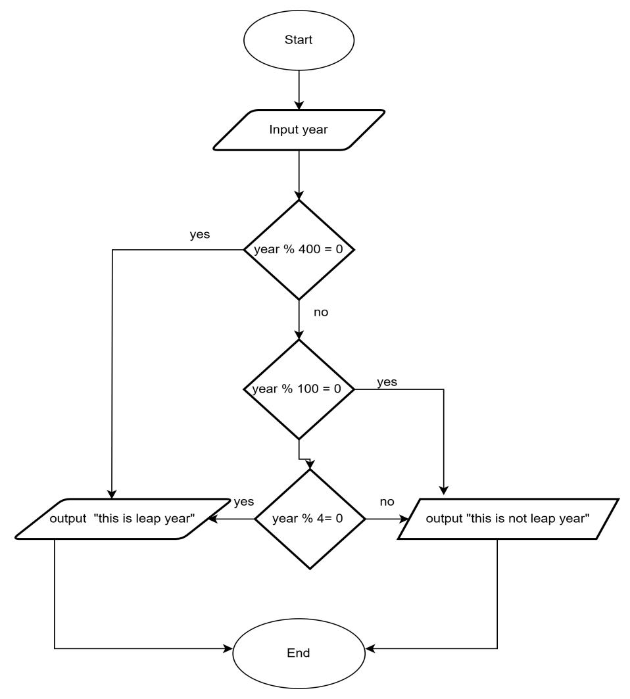

PseudoCode

Start

Input year

If (year mod 400 == 0) Then

Print "this is a leap year"

Else If (year mod 100 == 0) Then

Print "this is not a leap year"

Else If (year mod 4 == 0) Then

Print "this is a leap year"

Else

Print "this is not a leap year"

End If

End

1. **Take two numbers and print the sum of both.**

**FlowChart**

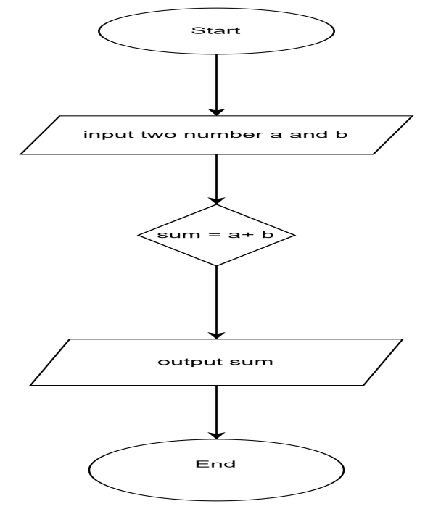

**PseudoCode**

Start

Input two number a and b

Sum = a + b

Output sum

End

1. **Take a number as input and print the multiplication table for it.**

**FlowChart**

